Data Science Career Track

Capstone 2 -

Milestone 2 Report

by Edward Franke

06/09/2019

Detect Pneumonia is chest x-rays Project – Milestone 1 Report

EXECUTIVE SUMMARY:

The purpose for this project is to find a correlation connected to chest x-rays containing pneumonia that can separate them in real time compared to normal healthy chest x-rays. The dataset is a cleaned dataset from Kaggle.com. Tensorflow and Keras has discovered some connections but further analysis is required. The second dataset has been a challenge and a solution yet to be discovered.

IDEA: A model to detect pneumonia is chest x-rays. (problem to solve)

CLIENT: Medical Industry

REASON: Pneumonia is a very serious condition that has the potential for death. I have personal knowledge of how serious it can be. The sooner it can be detected, the better the chance for survival and less damage to the lungs.

DATA: From Kaggle, 2 cleaned datasets with 5863 images and over 112,000 images.

SOLUTION: Create a model or analysis to discover what makes an x-ray image of the chest to have pneumonia and to capture this automatically.

DETAILS: See below.

DELIVERABLES: Code and a presentation outlining the discoveries.

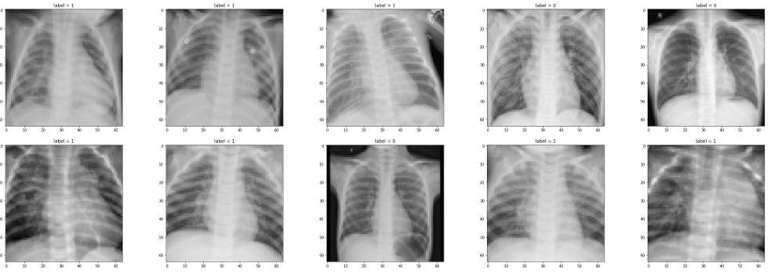

**Initial findings from exploratory analysis**

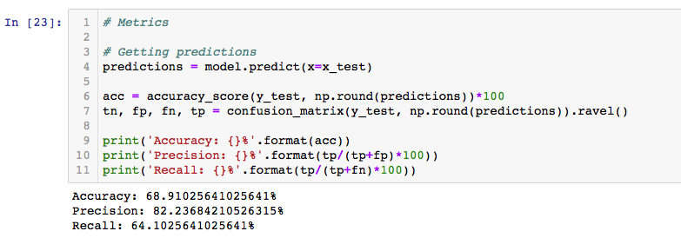

Tensorflow and Keras has discovered some connections but further analysis is required.

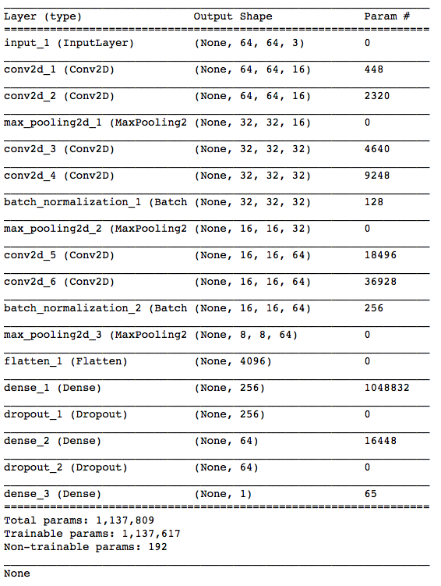

Update

All user code created for the second dataset have currently not worked in some degree. The most promising code has crashed the computer three times despite code changes. Using a merged code set from the first dataset to the second dataset has also been ineffective.

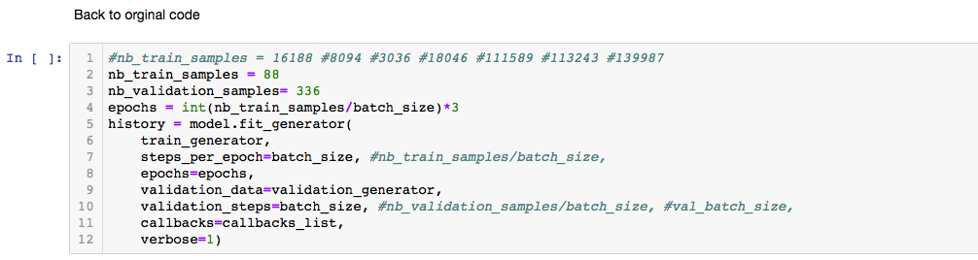

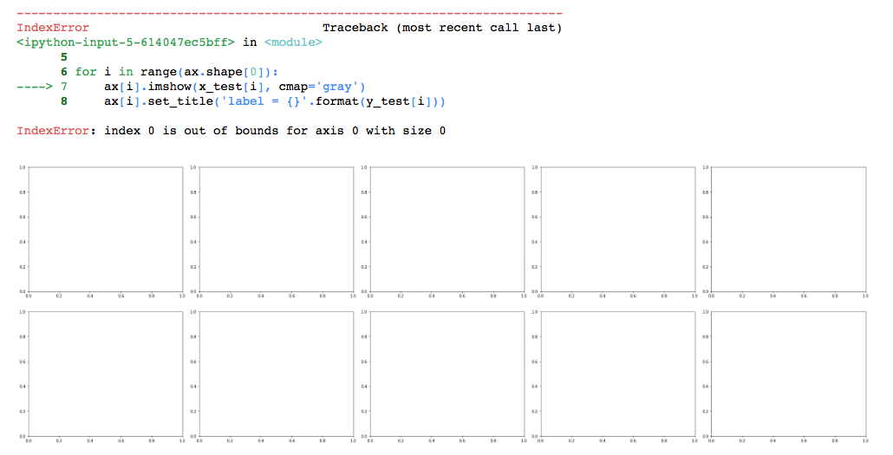

WHAT’S NEXT

Deep Dive

More code development and a solution found.

Further analysis to attempt greater accuracy and precision.

Final Report and Presentation